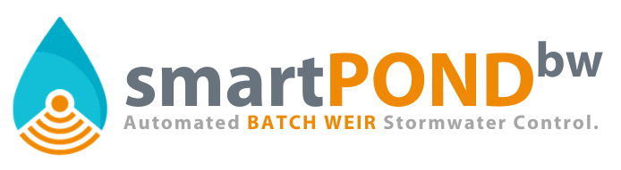

INSTALLATION GUIDE

- Introduction

The following specifications describe the components, general functions, and applications of smartPONDbw. The system functions as an electronically controlled stormwater management device, providing precision management capabilities and real-time in-field data. Using sensors, solar power, an electronic actuator, camera, and an internet-based control interface, smartPONDbw connects to a drainpipe to enable managers to precisely control surface water retention and detention remotely. The 24” rotary valve allows precise water level management with 1” resolution and only releases water from the surface. The control panel can be configured for full automation, real-time remote control, or scheduling of future events. Detention times, dewatering rates, dewatering depths and more can all be managed with the ARBDS. Constructed of ¼” powder-coated steel, smartPONDbw is built to last in harsh environments.

- smartPONDbw Applications in Stormwater Management

smartPONDbw is a device for active Stormwater management. As opposed to passive devices like a floating skimmer, active water management dramatically increases the efficiency and effectiveness of a detention pond. Where a passive skimmer or weir allows water to leave immediately upon collection, smartPONDbw can detain newly caught Stormwater and allow it to settle for a period of 12 hours before automatically dewatering. By releasing water only from the surface, settling pond characteristics can be maintained during dewatering.

- Installation

smartPONDbw can be installed in a near-completely assembled configuration. Only the battery and solar panel should be removed during the installation process. There are several ways to install smartPONDbw but these key points must be met to ensure proper function:

  - Leveling

smartPONDbw must be level when welded to the drainpipe, especially perpendicular to the levee or embankment.

  - Pipe Placement

To attach the drainpipe to smartPONDbw, first position the back plate against the drainpipe in the position it will be installed. When positioning smartPONDbw against the pipe, make sure that the bottom of the drainpipe aligns with the bottom of the smartPONDbw 24” drum. Use soapstone to trace the pipe against the back plate so that the hole may be cut out with a torch. With the hole cut out, smartPONDbw may be realigned with the pipe and welded.

  - Height Configuration

Depending on the site, smartPONDbw may require spacers to achieve the desired detention depth. Always allow at least 12” of space between the maximum valve height and levee height. The control box of smartPONDbw should never be configured less than 6” above the levee or embankment height.

  - Structure Support

If smartPONDbw is being installed on a pipe measuring less than 16” in diameter, permanent structural support such as a concrete pad or steel frame must be installed beneath the base of the device. Pipes larger than 16” in diameter can support the weight of smartPONDbw and therefore a permanent support structure beneath the device is optional. The standard fully assembled smartPONDbw weights 600 pounds. This does not include spacers or trash guards.

Quality Assurance and Performance Specifications

The quality of all system components and all other appurtenances and their assembly process shall be subject to inspection upon delivery of the system to the work site.

Installation is to be performed only by skilled work people with satisfactory record of performance on earthworks, pipe, welding, chamber, or pond/landfill construction projects of comparable size and quality.

